# Serverless

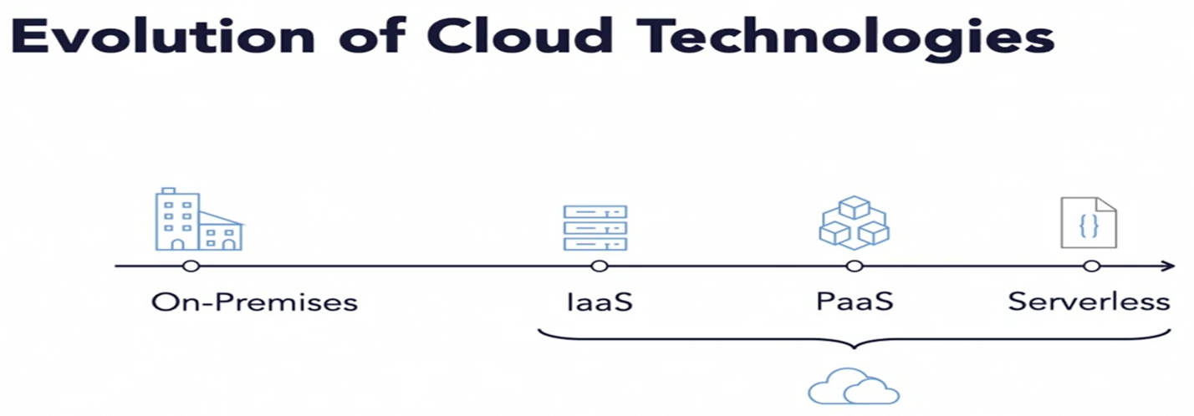

1. **What is Web App?**

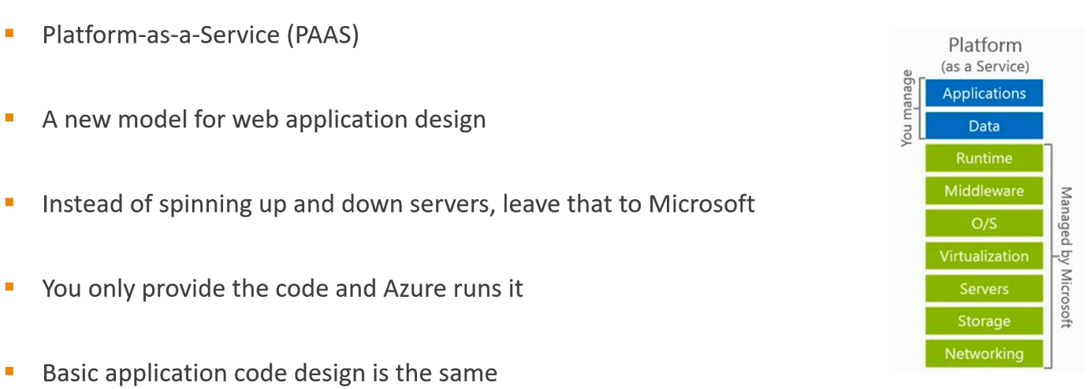

Even though in above, we only responsible for application and data, and rest infrastructure will be managed by Microsoft -> Still we must develop a monolithic application

* We have solution that might contains multiple projects -> these projects have sub-folders -> these sub-folders have dozens of cs files
* And we need to scale it -> we make more copies of the application.

Network Interface – All the data into VM passes via Network interface.

1. **What is serverless?**

Serverless doesn’t mean that something has no server -> It’s the services not server

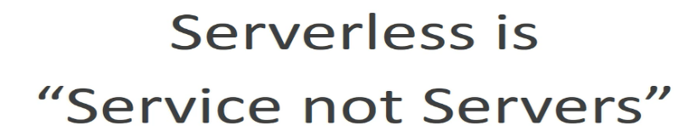

Microsoft provides these serveries and we just consuming these services -> its not in your server

|  |  |
| --- | --- |
| * Azure Function * Azure Logic Apps * Azure Bots * Machine Learning | These all are integrated with Azure Storage and Azure Database via API |

Serverless model is Event Driven -> Don’t have application that are always running, “no concept of continuous running”.

Require an event for something to happen, even a timer. -> Any trigger that can start and stop the application.

1. **Azure Function?**

* It is on demand, serverless code, completely managed
* On demand scaling -> means they scale dynamically.
* Support multiple programming languages.

|  |  |  |
| --- | --- | --- |
| Plan | Pros | Cons |
| Consumption Plan | Recommended | Can experience Cold Start - a bit delay function handle request |
| Pay Only when your Function running |
| Fast execute with Single responsivity -this plan gives more cost benefits |
| Scale Automatically |
|  |  |  |
| Premium Plan | We can avoid here cold start | Higher Prise |
| Vnet Connectivity |
| Unlimited execution duration |
| Premium Instance Size |
|  |  |  |
| App Service Plan | Reuse your existing App Service Plan | No Serverless |
| Dedicated VMs |

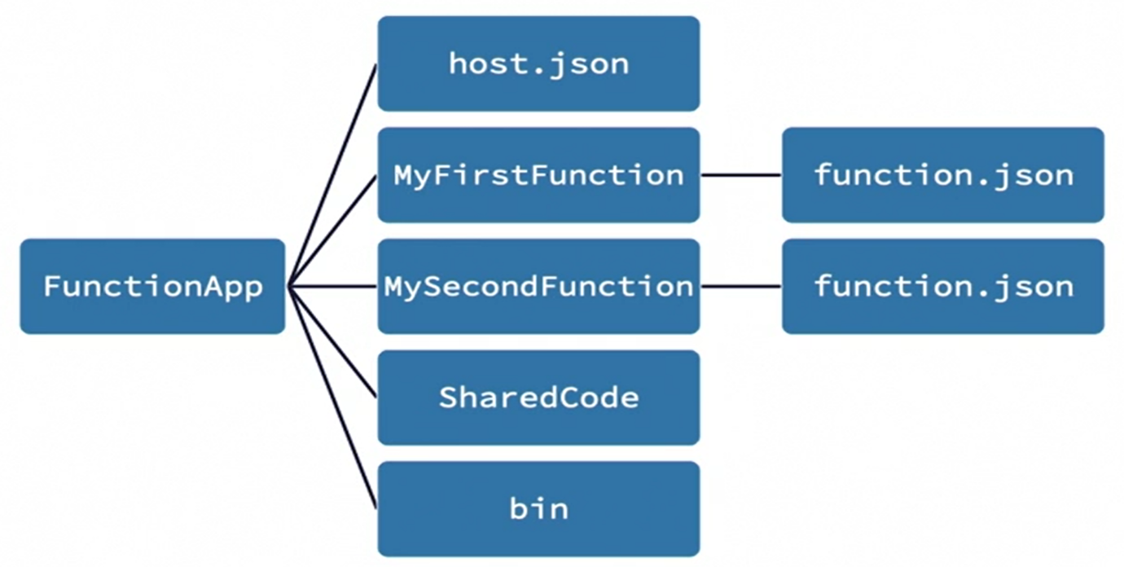

1. **Links to docs of serverless services:**

* Azure Functions: <https://docs.microsoft.com/en-us/azure/azure-functions/>
* Azure App Service: <https://docs.microsoft.com/en-us/azure/app-service/>
* Azure Kubernetes Service: <https://docs.microsoft.com/en-us/azure/aks/>
* Azure Cosmos DB: <https://docs.microsoft.com/en-us/azure/cosmos-db/>
* Azure Blob Storage: <https://docs.microsoft.com/en-us/azure/storage/blobs/storage-blobs-introduction>
* Azure Monitor: <https://docs.microsoft.com/en-us/azure/azure-monitor/>
* Azure Stream Analytics: <https://docs.microsoft.com/en-us/azure/stream-analytics/>
* Azure Logic Apps: <https://docs.microsoft.com/en-us/azure/logic-apps/>
* Azure Event Grid: <https://docs.microsoft.com/en-us/azure/event-grid/>
* Azure Service Bus: <https://docs.microsoft.com/en-us/azure/service-bus/>
* Azure API Management: <https://docs.microsoft.com/en-us/azure/api-management/>
* Azure DevOps: <https://docs.microsoft.com/en-us/azure/devops/?view=azure-devops>
* Azure Machine Learning: <https://docs.microsoft.com/en-us/azure/machine-learning/>
* Azure Cognitive Services: <https://docs.microsoft.com/en-us/azure/cognitive-services/welcome>

1. **Use Cases:**
   1. **Serverless Use Case: ETL**

ETL is the process which integrates different systems with data transformation.

Serverless architecture makes the job easier -> A trigger can fire when data available for transformation and reduce the time, and auto scale when with increase the data transfer rate.

**Let’s Take an Example:**

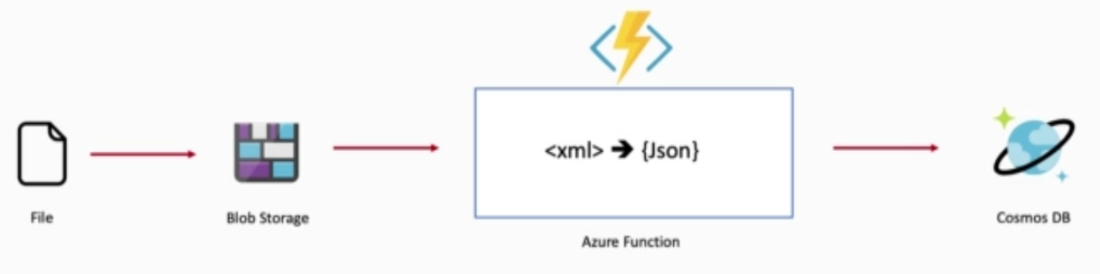

User Store the file (xml) into Blob storage -> as soon as file loaded, it needs to convert into JSON and then store into database.

We will setup Event Grid, which will trigger new event when new item added into Blob storage -> it send http request to function to process the request ( Convert xml data into JSON) -> once its done result will store into Cosmos DB.

* 1. **Serverless Use Case: Analysing Image**

Another use case is analysing image and convert it into thumbnail.

* Upload Image resize the thumbnail, call computer vision API to in cognitive services to recognize the content of image & save the metadata into database.
* Notify Admin for image uploaded.

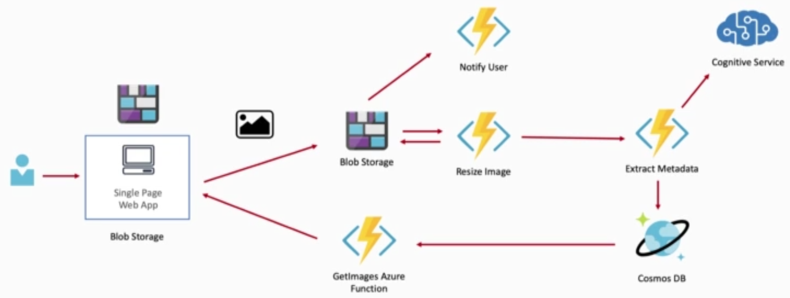

**Solution:**

* User upload image -> which store into Blob storage
* As soon as image uploaded -> Event Grid trigger the Function App -> Function will resize image into Thumbnail -> The Thumbnail store back into the blob storage
* Image then forward to another function which usage the cognitive services
* Finally, metadata stored into cosmos DB.
* Another function will fetch the image from database and return it back to application.

1. **SQL and NOSQL:**

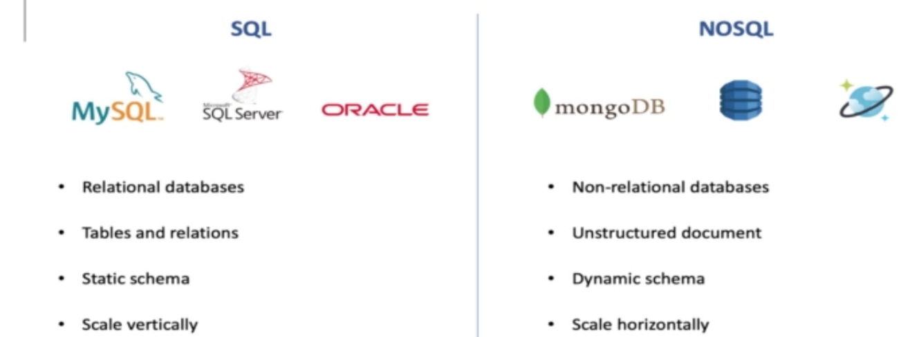

NoSQL will be preferred for application for which data is not relational or has no clear schema definition.

1. **Cosmos DB:**

* Cosmos DB is serverless NOSQL database, and we only pay for what we use.
* Single-digit millisecond response times, and automatic and instant scalability, guarantee speed at any scale.
* Azure Cosmos DB can be used to build IoT and telematics, retail and marketing, gaming and web and mobile applications.

Cosmos DB is multimodal database -> means we can model our data as documents, for which we have SQL API and Mango DB API

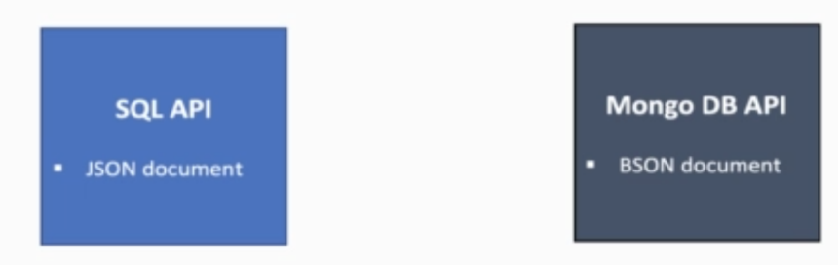

We can also model out data as key-value store using Table API. Using Grambling API we can model out data for Graph

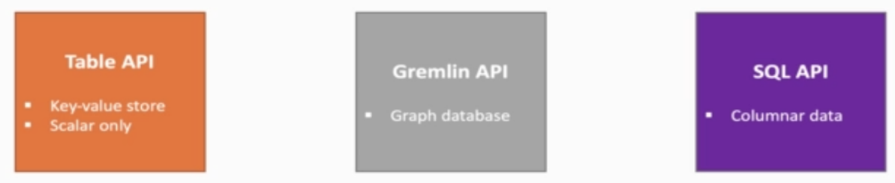

1. **Function Trigger:**

Every Azure function must have exact one trigger. i.e

* HttpTrigger
* Timetrigger
* BlobTrigger
* QueueTrigger

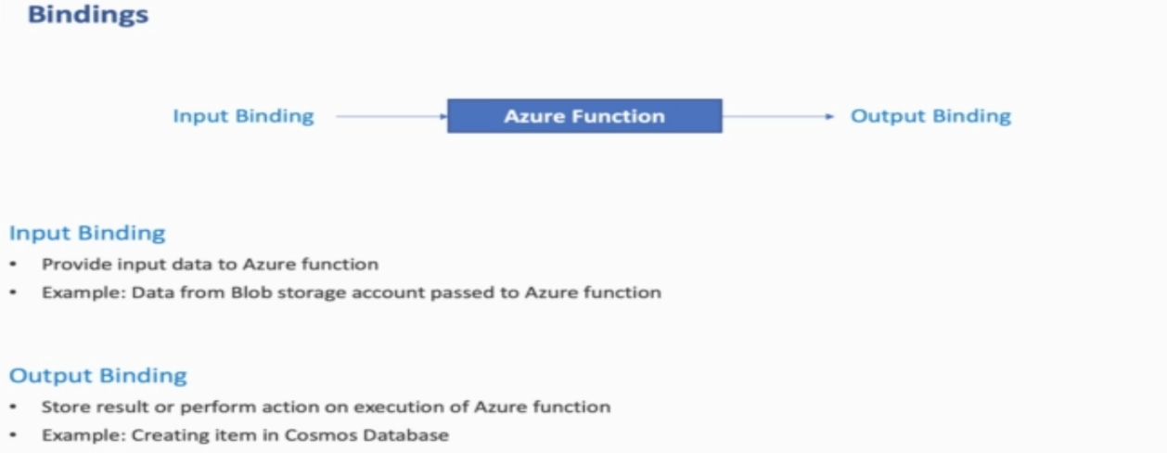

1. **Azure Function useful Resource:**

* Azure Functions Documentation: <https://docs.microsoft.com/en-us/azure/azure-functions/>
* Azure Functions Pricing: <https://azure.microsoft.com/en-us/pricing/details/functions/>
* List of triggers and bindings: <https://docs.microsoft.com/en-us/azure/azure-functions/functions-triggers-bindings#supported-bindings>
* Timer trigger cron format helper: <https://crontab.guru/>

1. **What going to build:**

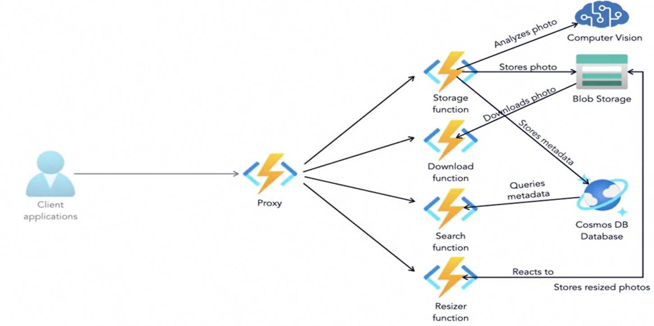

* Storage function will store the phone into Blob storage
* Additionally, Storage function store the photo metadata into CosmosDB
* Using dependency injection technique, we inject computer vision API to validate the image
* Resizer function will responsible to resize the image into appropriate size and store back to another blob location.
* Search function will use to search the photos
* Download function will download the photo
* Proxy function to route the client request.

1. **Function – Trigger and Binding:** 
   1. **Trigger**

* Specify how a function can be invoke
* Function only can have one trigger
* Have associated data
  1. **Bindings**
* Allow to connect data to and from a Function
* Function can have multiple input or output binding.



* 1. **Review of Release Pipeline**
  2. **ARM Template for release Pipeline**

1. **Terraform**
   1. **DevOps Task before automation:**

DevOps task before applying automation ->

**Step1:** Go manually setup server, configuring network on those servers, install all necessary software, configure software (i.e. may be required .net version), install database for application in order to make your application to run on that server. -> All these things manually done by system administrator for your application

**Which causes:**

* Higher human resource cost
* More effort and time
* More human error possible

**Step 2:** step 1 demonstrate the setup phase, and after the setup you may need maintenance.

* Update version of software
* Deploy new release
* DB backup/ updates
* Recover App if it crashed
* Add recover server if it crashed
* Change networking configuration

All these things again manually effort

We can automate all above things -> this process known as Infrastructure as code.

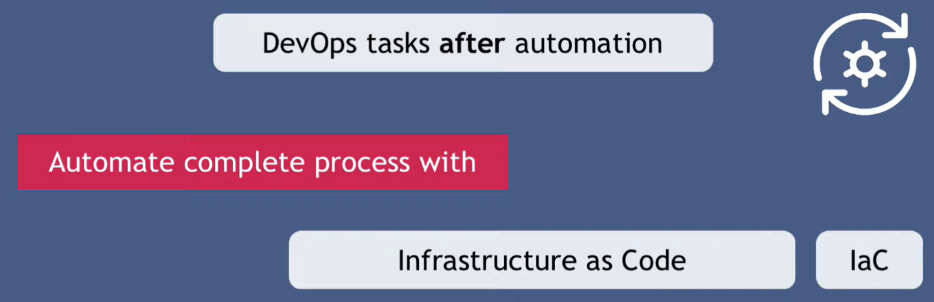

Terraform, puppet, Ansible are the tool that are used for orchestrating the infrastructure as code.

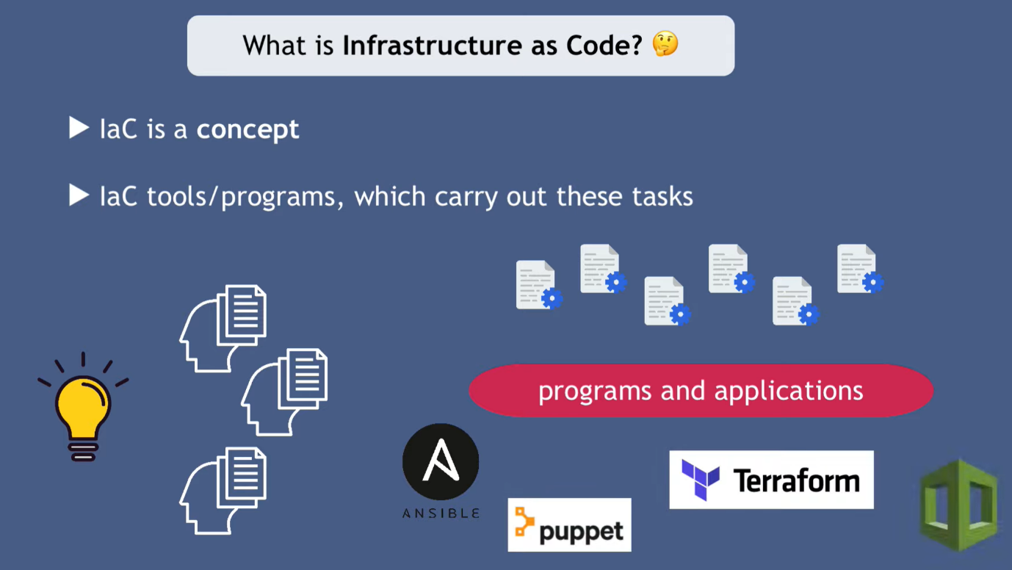

* 1. **Limitation of IaC Tools:**

Not a single tool is capable enough to do all above task. There are 3 main category ->

**1 Infrastructure Provisioning:**

* Spinning up new servers
* network configuration
* creating load balancers
* configuration on infrastructure level

**2 Configuration of provisions infrastructure**

* installing apps on servers
* managing those apps
* prepare the infrastructure/servers to deploy your app (live install .net, install DB)

**3 Deployment of your application**

With docker container technology -> the configuration and deployment steps can be merged

With docker you take your application and all the configuration together and package it and deploy it to needed environment, so configuration is already there in image itself. -> There fore when you run your application on docker, everything setup into container

* 1. **Difference of Ioc Tools:**

Let’s see what different IoC tool can do

1. Terraform: is not very useful for maintenance of application.

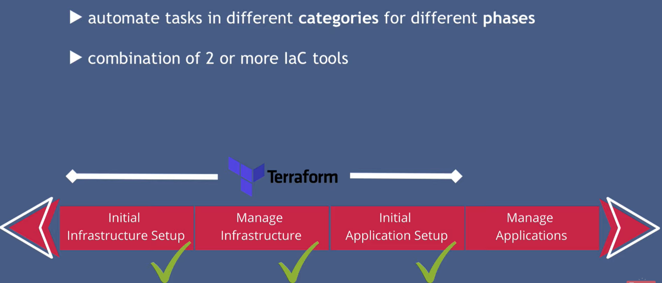

1. CHEF, puppet and Ansible cannot do initial infrastructure setup.

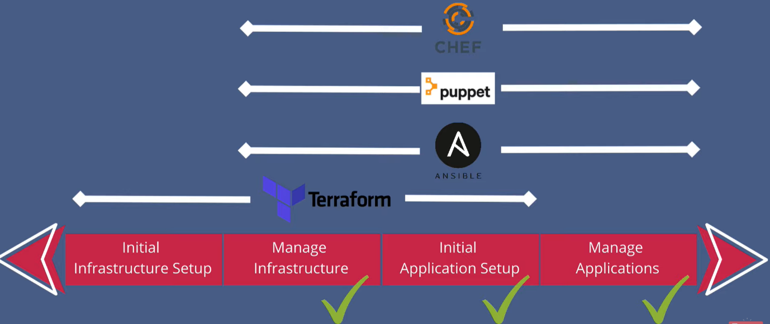

So people usage -> Terraform to provision and configure infrastructure -> Ansible to install and deploy application

* 1. **What is Terraform:**

Terraform is the infrastructure as code offering from hashicorp, that automate and manage your infrastructure, and the services that run on that infrastructure.

Tool used for building, changing and managing infrastructure in sage and repeatable way.

Human readable, reusable and used to automate cloud deployment

Support coding best practice, such as version control, testing and deployments.

* Terraform usage declarative language -> it means you don’t have to define every step on how to this automation and management is done ->
* You just declare what you want -> The final result or end result -> terraform will figure out how to execute it.

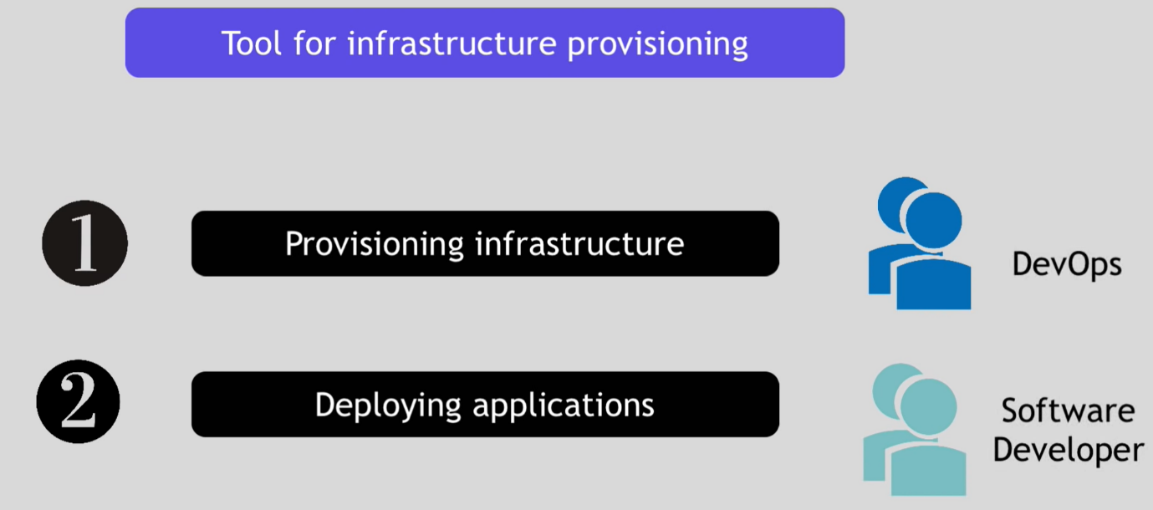

* 1. **Important Links and Docs:**

Course Github Repository Links

* Course Main Github Repository: [terraform-on-azure-cloud](https://github.com/stacksimplify/terraform-on-azure-cloud)
* Azure IaC DevOps Git Repository: [terraform-on-azure-with-azure-devops](https://github.com/stacksimplify/terraform-on-azure-with-azure-devops)
* Course Presentation: [Terraform-on-Azure-Cloud-v9.pptx](https://github.com/stacksimplify/terraform-on-azure-cloud/blob/main/course-presentation/Terraform-on-Azure-Cloud-v9.pptx)
* [Terraform Certified documents](https://github.com/stacksimplify/hashicorp-certified-terraform-associate-on-azure)
* Real time Terraform [files](https://github.com/stacksimplify/terraform-on-azure-cloud) and Demo
  1. **Terraform Installation:**

**Step 1:** Go to terraform.io -> download CLI for Windows -> Store file & folder somewhere in C drive (C:\terraform) -> configure the path into environment variable

Click Start -> Click Settings -> Click System -> Search Environment -> Click Edit the system environment variable

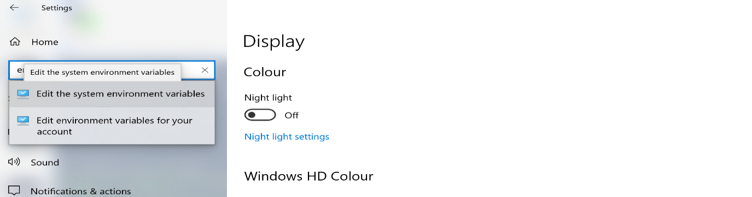

**Step 2:** Go to path and add terraform folder location

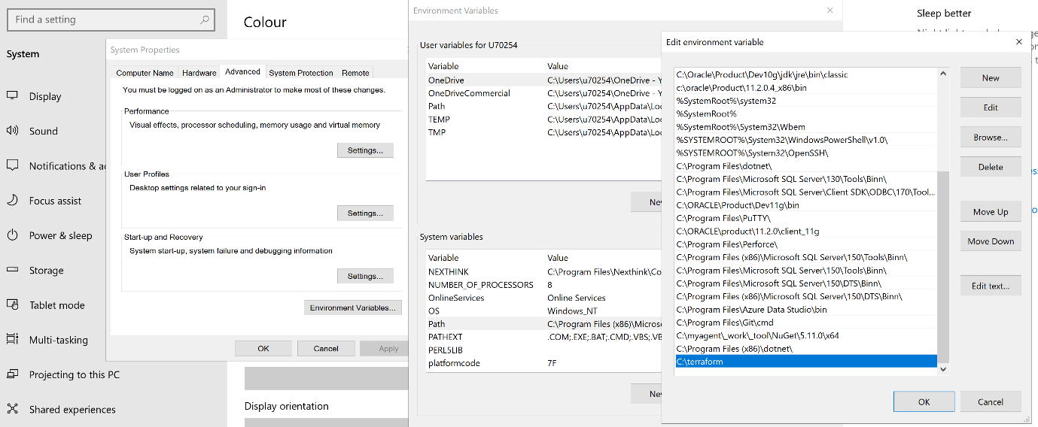

* 1. **Install all the tools required**
* Install [Terraform CLI](https://www.terraform.io/downloads.html)
* Install [Azure CLI](https://docs.microsoft.com/en-us/cli/azure/install-azure-cli)
* Install [VS Code Editor](https://code.visualstudio.com/download)
* Install [HashiCorp Terraform plugin for VS Code](https://marketplace.visualstudio.com/items?itemName=HashiCorp.terraform)
* Install [Git Client](https://git-scm.com/downloads)

Pre-Conditions-1: Get Azure Regions and decide the region where you want to create resources

# Get Azure Regions -> az account list-locations -o table

Pre-Conditions-2: If not done earlier, complete az login via Azure CLI. We are going to use Azure CLI Authentication for Terraform when we use Terraform Commands.

# Azure CLI Login -> az login

# List Subscriptions -> az account list

# Set Specific Subscription (if we have multiple subscriptions) ->

az account set --subscription="SUBSCRIPTION_ID"

* 1. **Terraform Workflow:**

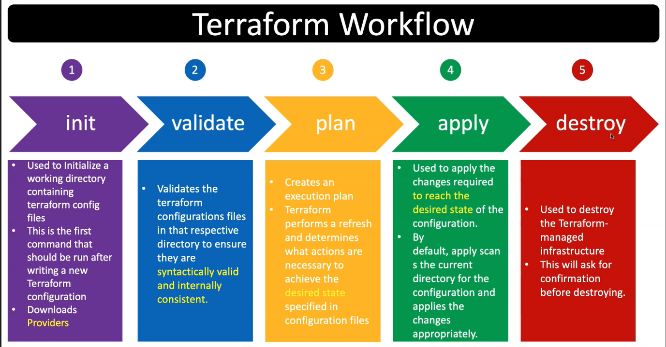

1. **ARM Vs Terraform:**

ARM templates and Terraform are both Infrastructure as Code tools for deploying cloud resources. A very high-level summary of the differences is below

**ARM Templates**

* Azure specific
* Get the latest Azure resources as they are released
* Does not maintain a state file
* Written in JSON
* Does not have a Destroy/Clean-up command

**Terraform**

* Supports multiple cloud providers and on-prem resources
* Can lag behind when new Azure resources are released
* Relies on a state file that must be maintained
* Written in HCL, a custom DSL from Hashicorp
* Able to clean up/destroy resources

Both tools can be used to create resources in Azure, they both have positives and negatives compared to each other.

1. **Pre-requisite to run Terraform command:**

**Pre-Conditions-1:** Get Azure Regions and decide the region where you want to create resources

# Get Azure Regions

az account list-locations -o table

**Pre-Conditions-2:** If not done earlier, complete az login via Azure CLI. We are going to use Azure CLI Authentication for Terraform when we use Terraform Commands.

# Azure CLI Login

az login

# List Subscriptions

az account list

# Set Specific Subscription (if we have multiple subscriptions)

az account set --subscription="SUBSCRIPTION_ID"

1. **Terraform Language Basic:**

A terraform file contains four different blocks.

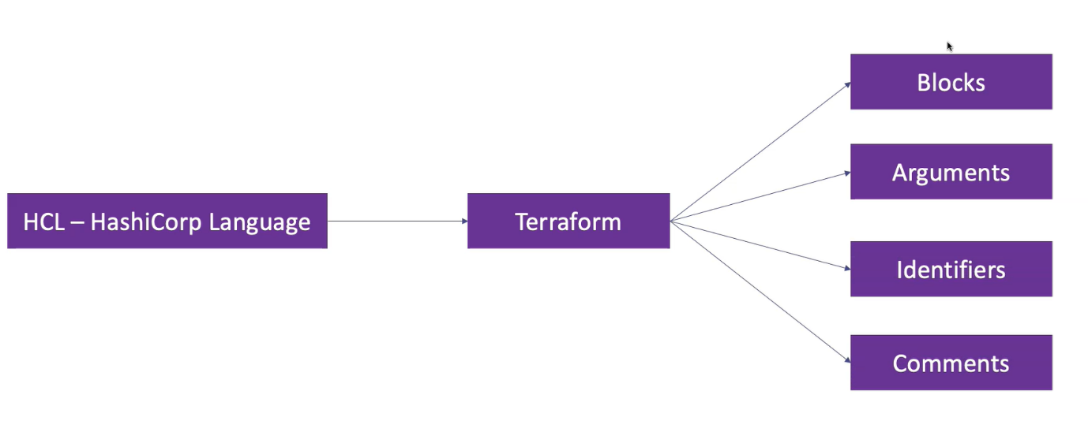

terraform {

  required_version = ">= 1.0.0"

  required_providers {

    azurerm = {

      source = "hashicorp/azurerm"

      version = ">= 2.0" # Optional but recommended in production

    }

  }

}

# Configure the Microsoft Azure Provider

provider "azurerm" {

  features {}

}

# Create Resource Group

resource "azurerm_resource_group" "my_retail_rg" {

  location = "eastus"

  name = "my-retail-rg"

}

1. **Terraform top level block**

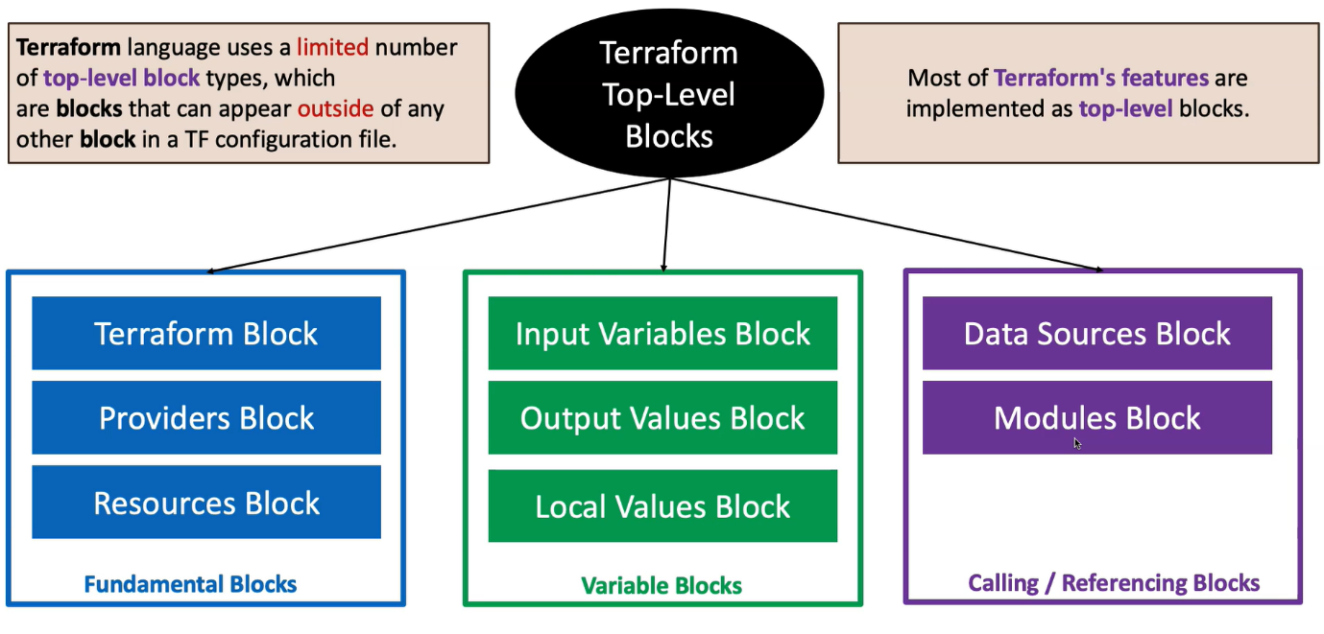

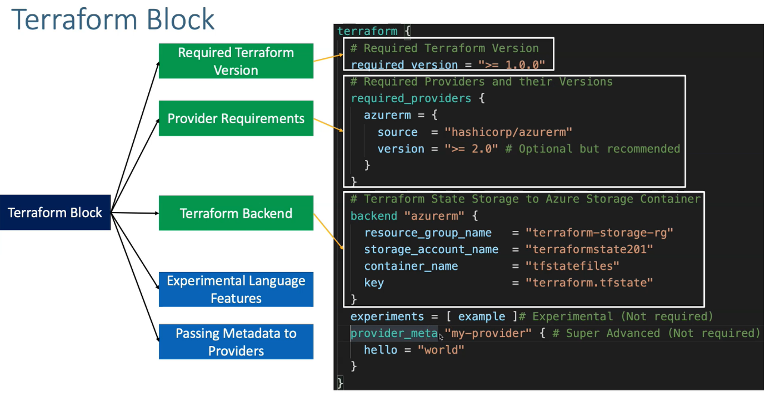

1. **How Terraform Command Works**

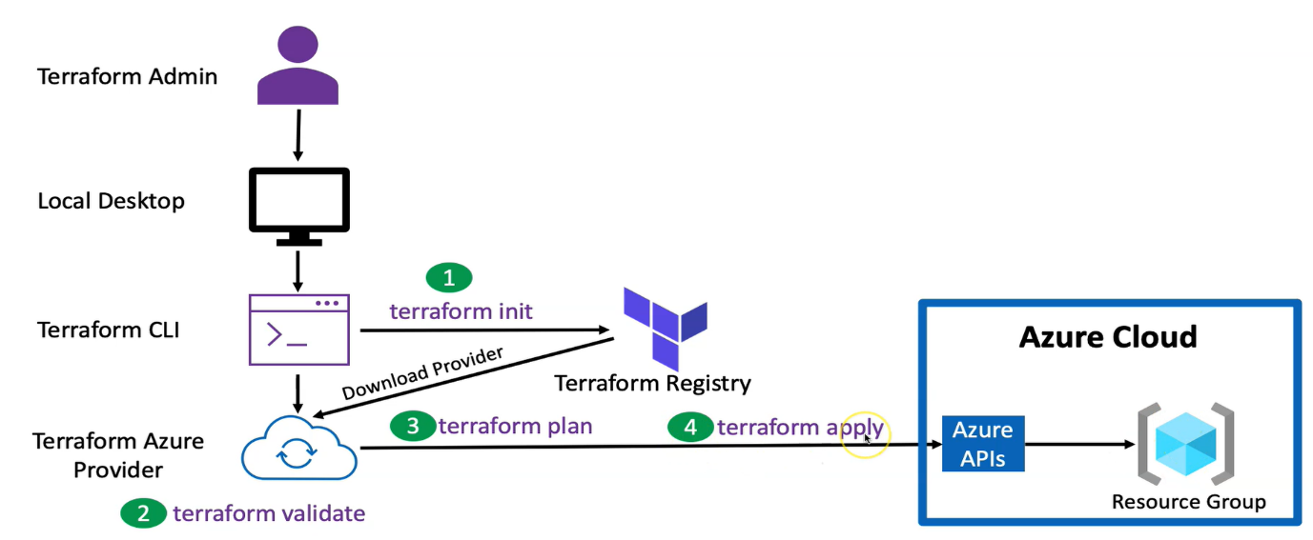

* When we run init command, terraform registry download the terraform provides (here it is Azure, it could be anything AWL, Google cloud..)
* When run terraform validate -> it validate the terraform configuration, evaluate the syntax is valid or invalid
* When we run terraform plan -> provider start communicating with could APIs & generates the plan
* When run terraform apply -> the actual implementation starts and resource created into Azure subscription.
* When run terraform destroy -> resource deleted

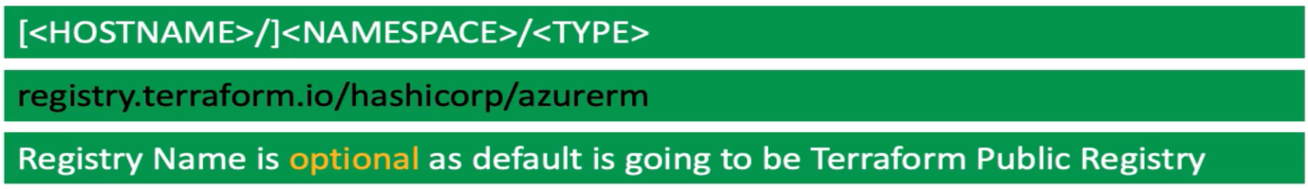

1. **Terraform Multi-Providers**

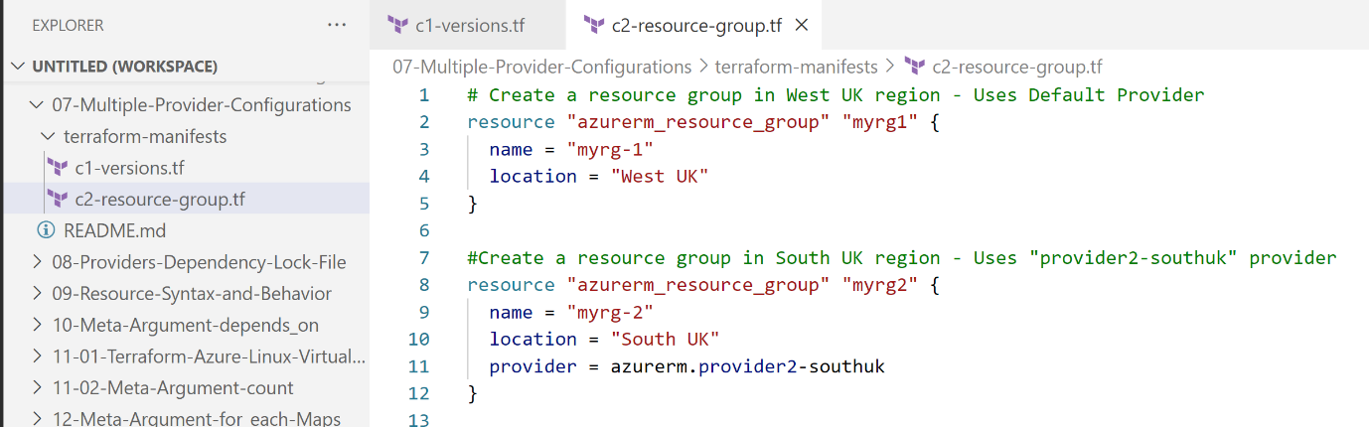

Here two resources are created -> One with provider (azurerm) at West UK location and another one by provide (azurerm.provider2-southuk)

1. **Terraform Dependency Lock File:**

Terraform configuration refers two different kinds of external dependency that come from outside of its own code base.

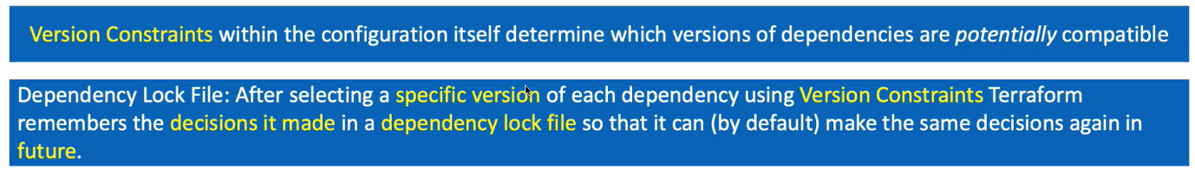

terraform {

  required_version = ">= 1.0.0” -> It automatically usages latest version

1. **Terraform Desired state and current states**

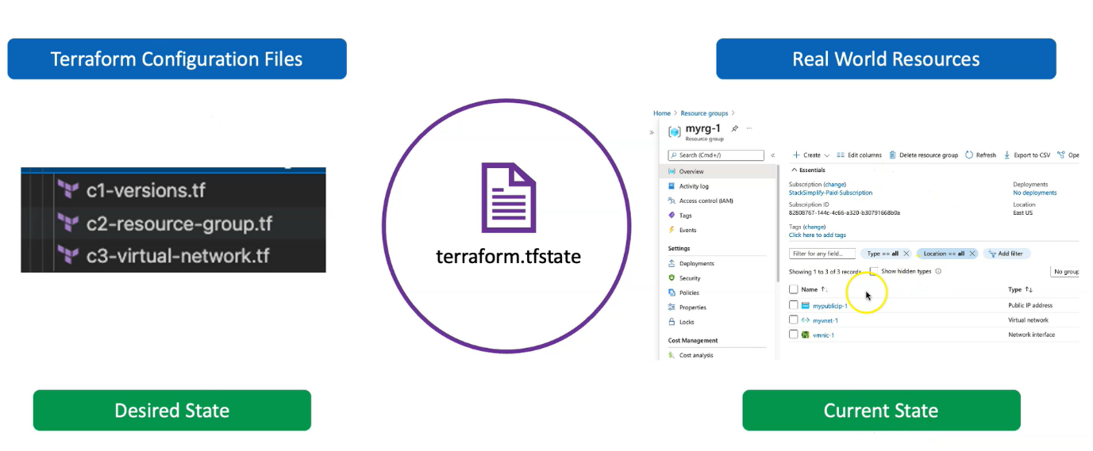

The real current states details can be found into tfstate file.

1. **Design Azure Virtual Network 4 tier:**

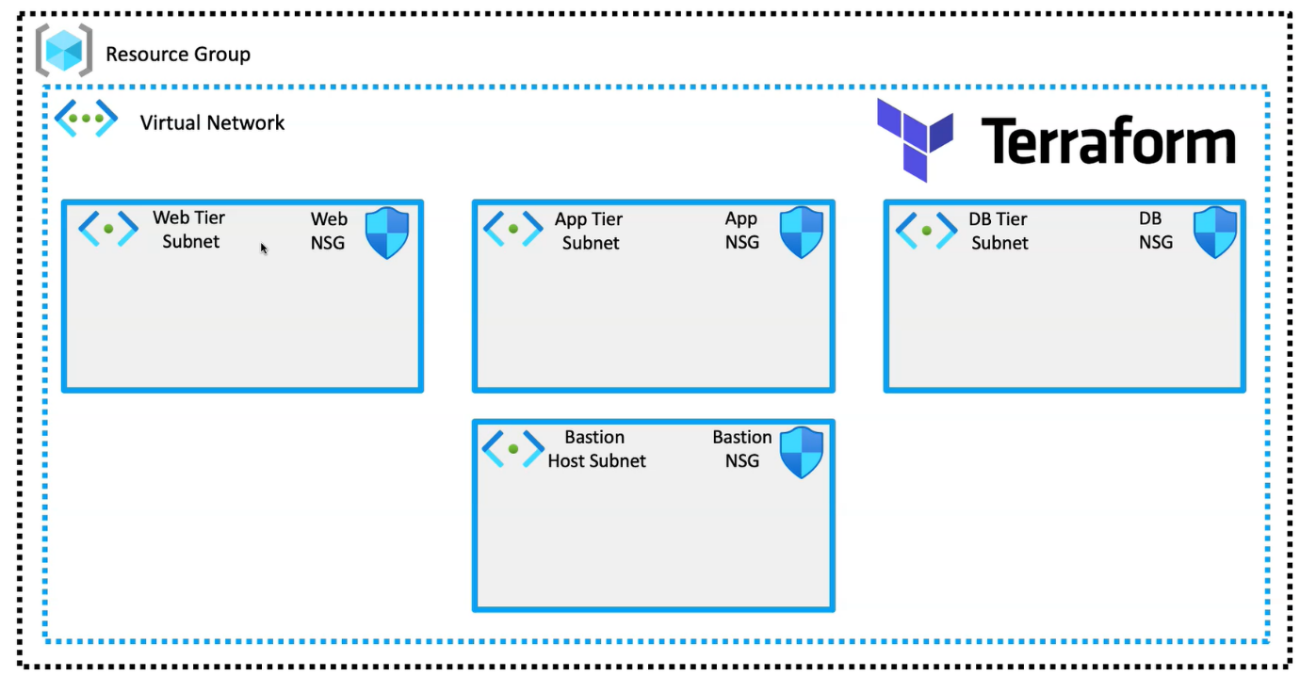

Refer to ->

C:\TerraformDevelopment\Dev2\10-Azure-Virtual-Network-4Tier\terraform-manifests

* 1. **Random Provider:**

The random provider allows the use of randomness within terraform configuration. For example: if you need to create a storage account -> then name of storage account should be unique -> but how we can aware the uniqueness when define name using variable

For this we use random provider. - [Random](https://registry.terraform.io/providers/hashicorp/random/latest/docs/resources/id)

* 1. **Depends On:**

# Resource-3: Associate NSG and Subnet

resource "azurerm_subnet_network_security_group_association" "web_subnet_nsg_associate"

{

depends_on = [ azurerm_network_security_rule.web_nsg_rule_inbound] # Every NSG Rule Association will disassociate NSG from Subnet and Associate it, so we associate it only after NSG is completely created - Azure Provider Bug https://github.com/terraform-providers/terraform-provider-azurerm/issues/354

subnet_id                 = azurerm_subnet.websubnet.id

network_security_group_id = azurerm_network_security_group.web_subnet_nsg.id

}

Depends on – signifies that creation of resource B after that creation of resource A is completed.

* 1. **Output tf file:**

Output values are like return value of a terraform module.

* It returns detail information about resources in the CLI output after running terraform apply.
* A child module can use outputs to expose a subset of its resource attributes to its parent module.

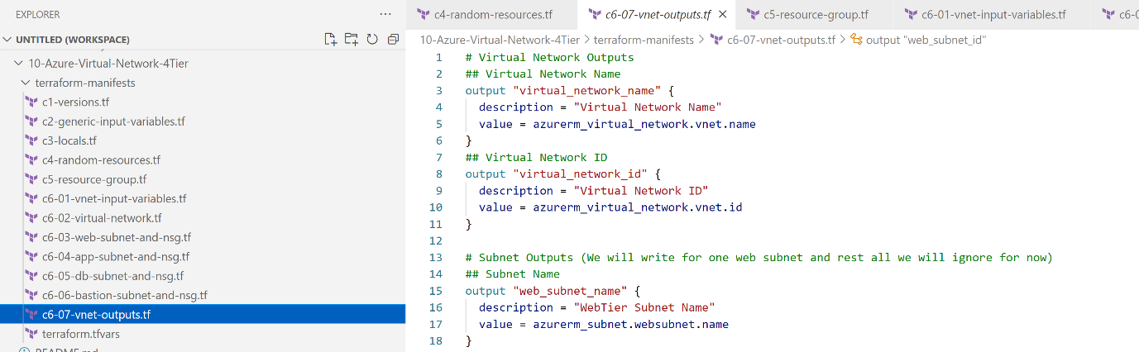

* 1. **terraform.tfvars:**

This is used to override the values of variables defined. This file automatically loaded when we run terraform apply and override the values of variables.

Even you don’t need to define the value of variable, we can use this file to set the value of variables.

1. **Windows Virtual Machine using Terraform:**

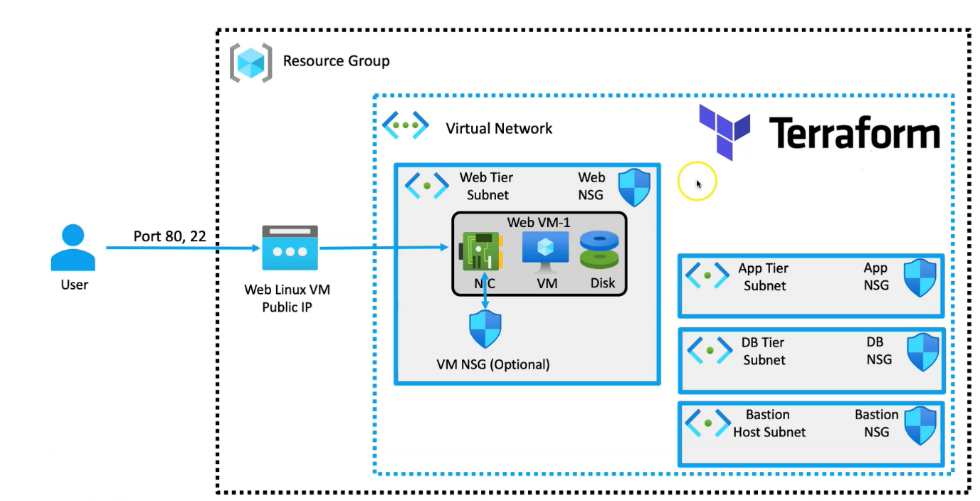

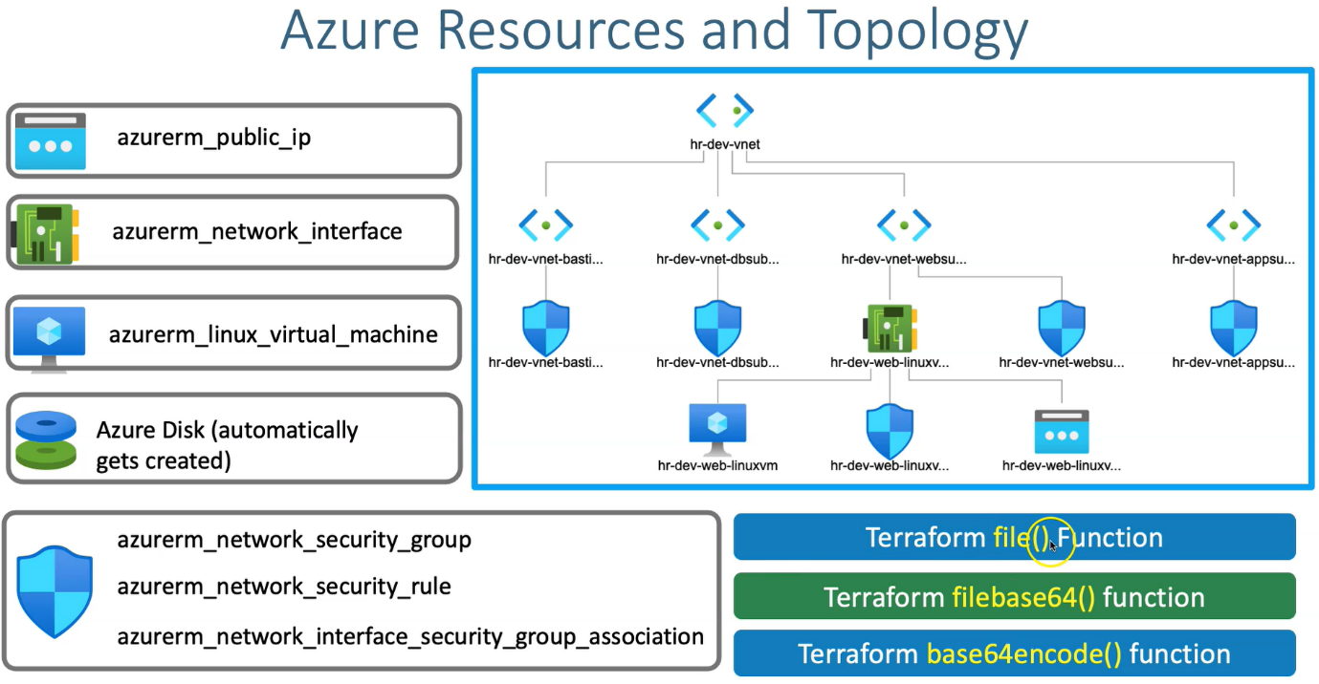

Refer to ->

C:\TerraformDevelopment\Dev2\11-Azure-Windows-Virtual-Machine\terraform-manifests

1. **Azure Bastion Host Windows VM:**

In above, we use public IP to access the VM, due to security reason we don’t recommend to use public IP. Here we will setup Bastion host. User will access VM via Bastion host.

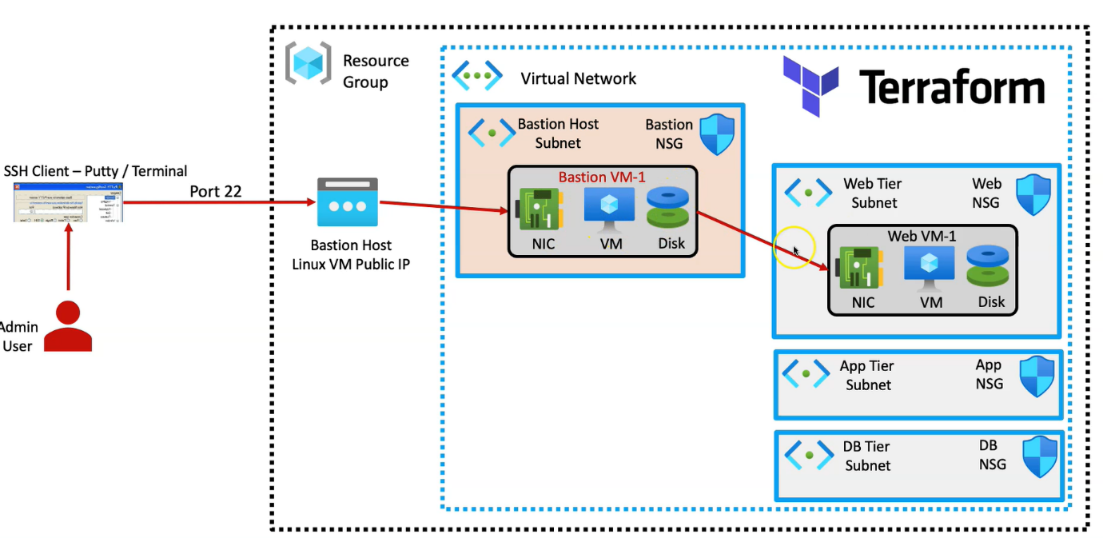

Another way is -> using the Azure Bastion service -> Azure come up with service to RDP and SSH security by connecting to Virtual Network.

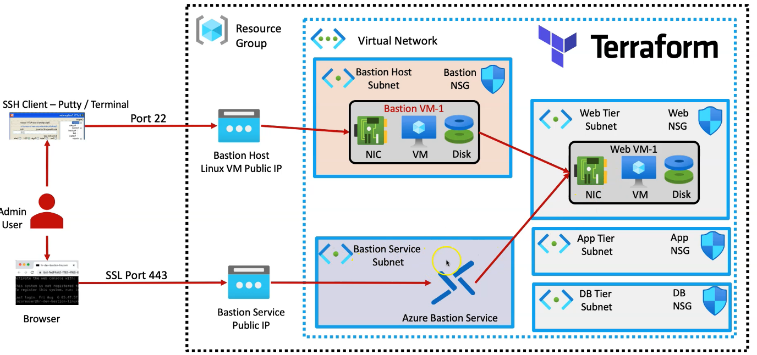

Refer to -> C:\TerraformDevelopment\Dev2\12.1-Azure-Bastion-Service-and-Host\terraform-manifests

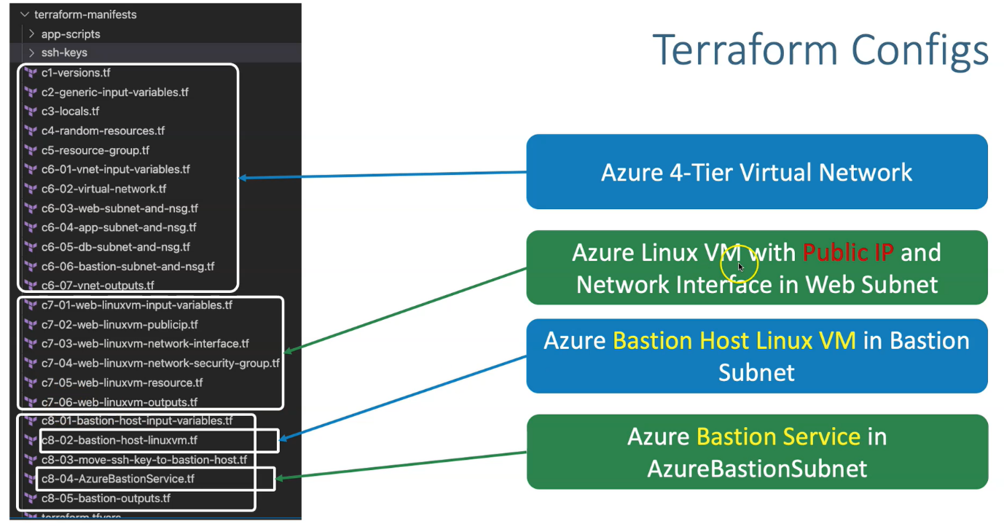

Here we are creating another Bastion service subnet -> Because it requires a dedicated separate subnet that not going to share with Bastion Host subnet.

# We have creating two subnet -> one for Azure Bastion Host that have another VM configure, which will use to connect with VM having private IP

# Another one is Azure Bastion Service -> By which we can directly connect to VM having private IP

1. **Azure Load Balancer:**

Now we are going to setup a infrastructure like below.

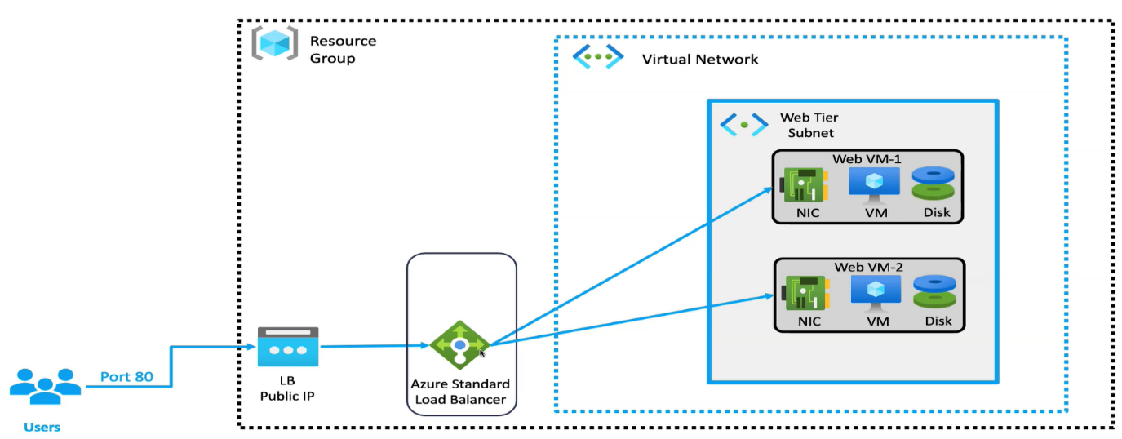

Refer to -> C:\TerraformDevelopment\Dev2\14.1-Azure-Standard-LoadBalancer-Basic\terraform-manifests

* 1. **NAT Rule:**

If we disassociate the public IP for both VM -> then we cannot direct RDP to those VM. Now if we put both VMs behind the load balancer and accessing application through public IP of load balancer.

In this case -> we can setup NAT rule in load balancer to RDP the VMs using public IP of load balancer

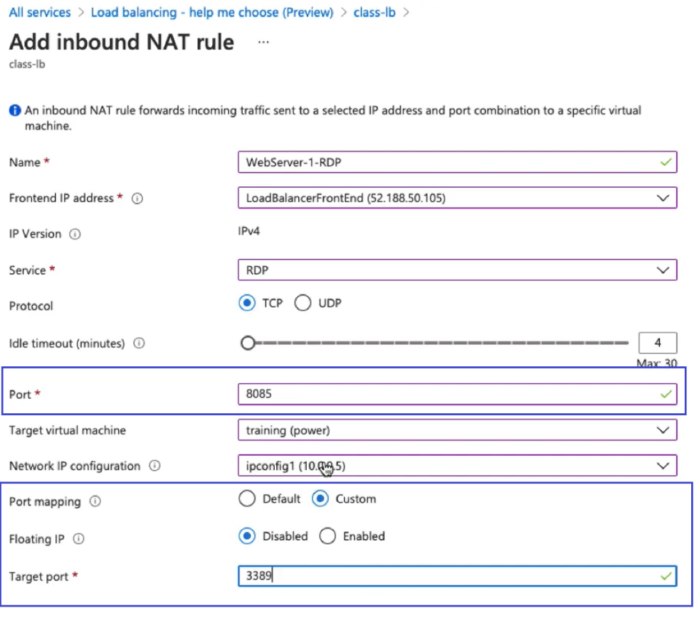

Set the Port number different for both VMs for which you want to do RDP via public IP of load balancer. -> and then defined port mapping with 3389 to RDP VM.

Note: Create another NAT rule for second VM

Now you can connect VMs suing public IP of Load Balancer

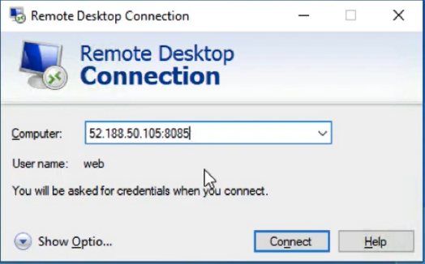

1. **Terraform Meta Arguments:**

Now we are going to create multiple instance of resources (like multiple VMs), writing code for every VM is a tedious task. S by using terraform Meta Arguments we can easily manage such requirements.

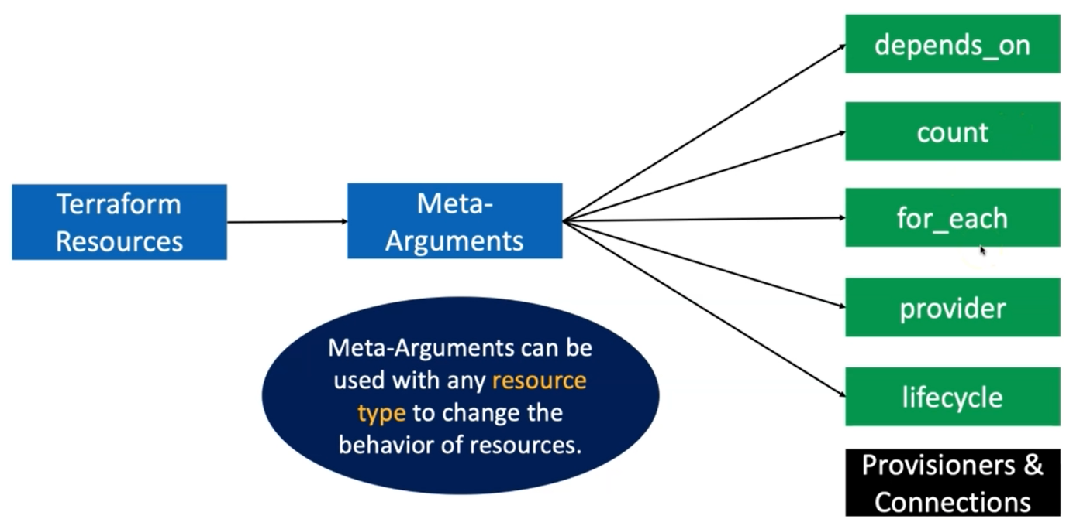

* 1. **What we going to build now**

Here we are going to create multiple VMs behind the load balancer. VMs doesn’t have public IP -> so we can’t do RDP directly.

We will create NAT rule for each VM to do RDP via public IP of Load Balancer.

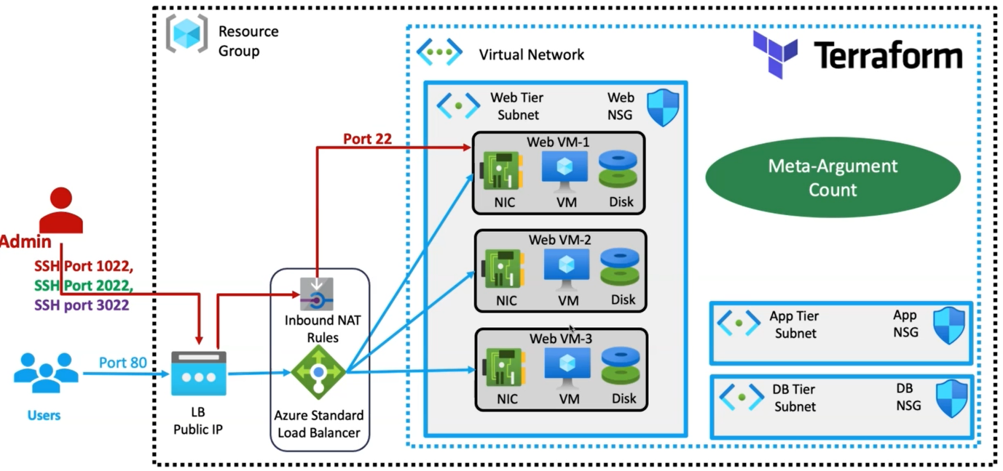

If we are going to create 5 VMs ->

* then we must create 5 network interfaces.
* 5 security group (optional)
* 5 virtual machines
* 5 NAT rules

1. **Azure Virtual Machine Scale Set**

What we are going to build using terraform.

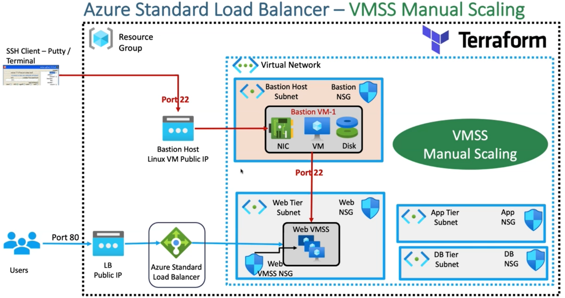

1. **Azure IaC DevOps for Terraform Project:**

We are going to prepare 4 environments to deploy IaC platform using terraform

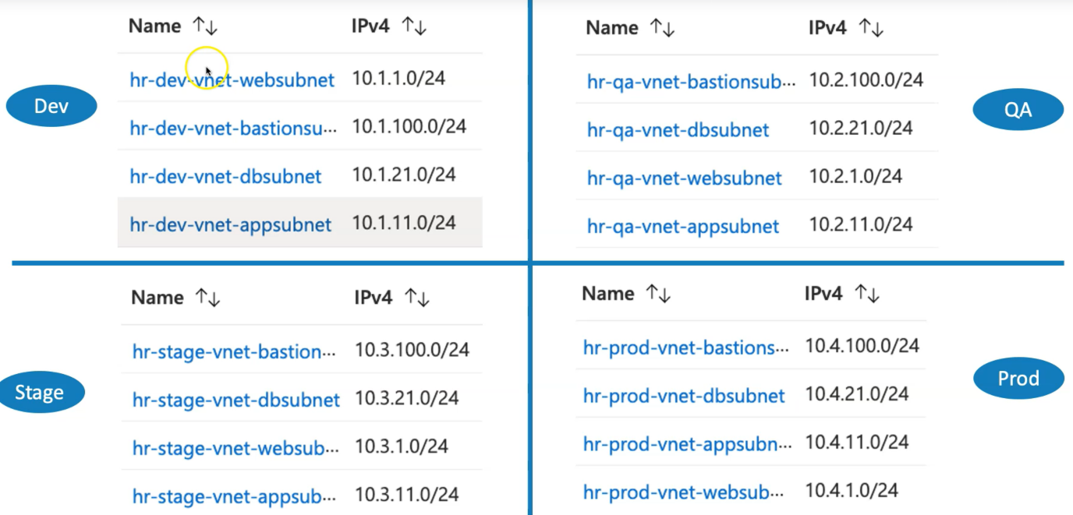

* 1. **Create Azure DevOps Organization**
* Navigate to https://dev.azure.com
* Click on Sign into Azure DevOps
* Provide your Azure Cloud admin user
* Click on Continue
  1. **Install Terraform Extension for Azure DevOps**

[Terraform Extension for Azure DevOps](https://marketplace.visualstudio.com/items?itemName=ms-devlabs.custom-terraform-tasks)

* 1. **Create Service Connection for Azure DevOps**

From Azure DevOps -> we are going to provision infrastructure into Azure Cloud -> So we need to create service connection

* Go to Azure DevOps -> Organization (stacksimplify1) -> Project (terraform-on-azure-with-azure-devops) > Project Settings -> Pipelines -> Service Connections
* Click on New Service Connection
* Choose a service or connection type: Azure Resource Manager
* Authentication Method: Service principal (automatic)
* Scope level: Subscription
* Subscription: Select Subscription if we have many
* Username: Azure Cloud Admin User
* Password: XXXXXXXXX
* Resource Group: leave empty
* Service connection name: terraformiacdevops1
* Description (optional): terraformiacdevops1 Service Connection used for CICD Pipelines
* Security: CHECK Grant access permission to all pipelines (leave to default checked)
* Click on Save

If getting any service connection error ->

[Refer to link](https://stackoverflow.com/questions/58104257/failed-to-create-an-app-in-azure-active-directory-insufficient-privileges)

&

[Route to this link](https://docs.microsoft.com/en-us/azure/devops/pipelines/release/azure-rm-endpoint?view=azure-devops#the-user-has-only-guest-permission-in-the-directory)

* 1. **Create Storage Account for storing Terraform State Files**
* Create Storage Account, Storage Container if not created.
* We have already created that as part of Section-24-Step-02 which will re-use here.

# Terraform State Storage to Azure Storage Container

resource_group_name = "terraform-storage-rg"

storage_account_name = "terraformstate201"

container_name = "tfstatefiles"

key = "dev-terraform.tfstate"